1: Copy the file “googleplay-priv-app” to the root directory of the U disk, and plug into IWB.

Mark: Don't unzip the file.

2:Find this path. “Setting”→”About device”

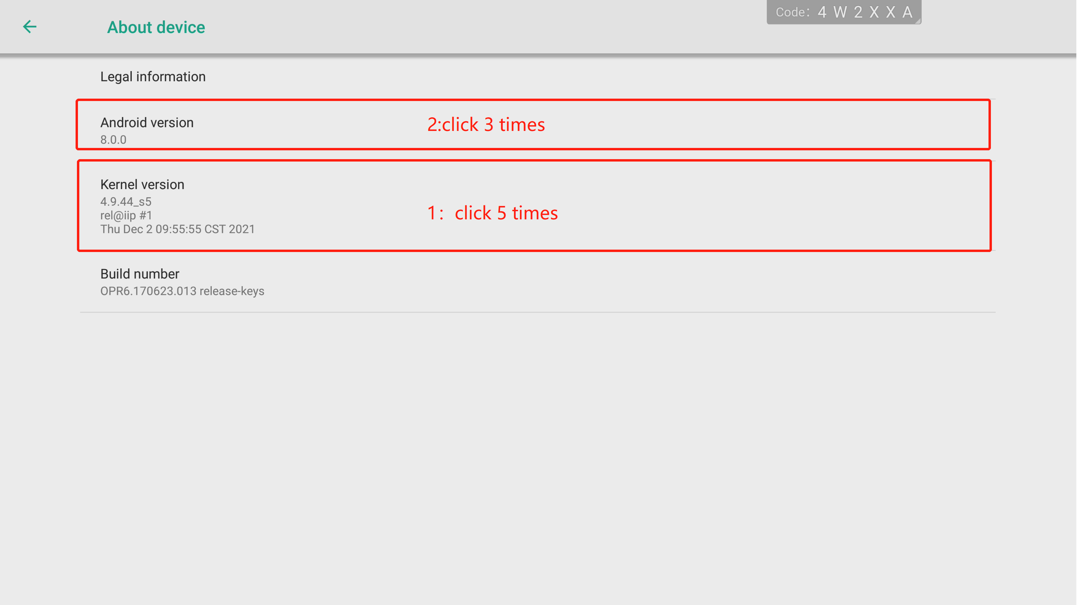

3:Enter debug mode.

Step 1: Quick click “Kemel version” five times.

Step 2: Quick click “Android version” three times.

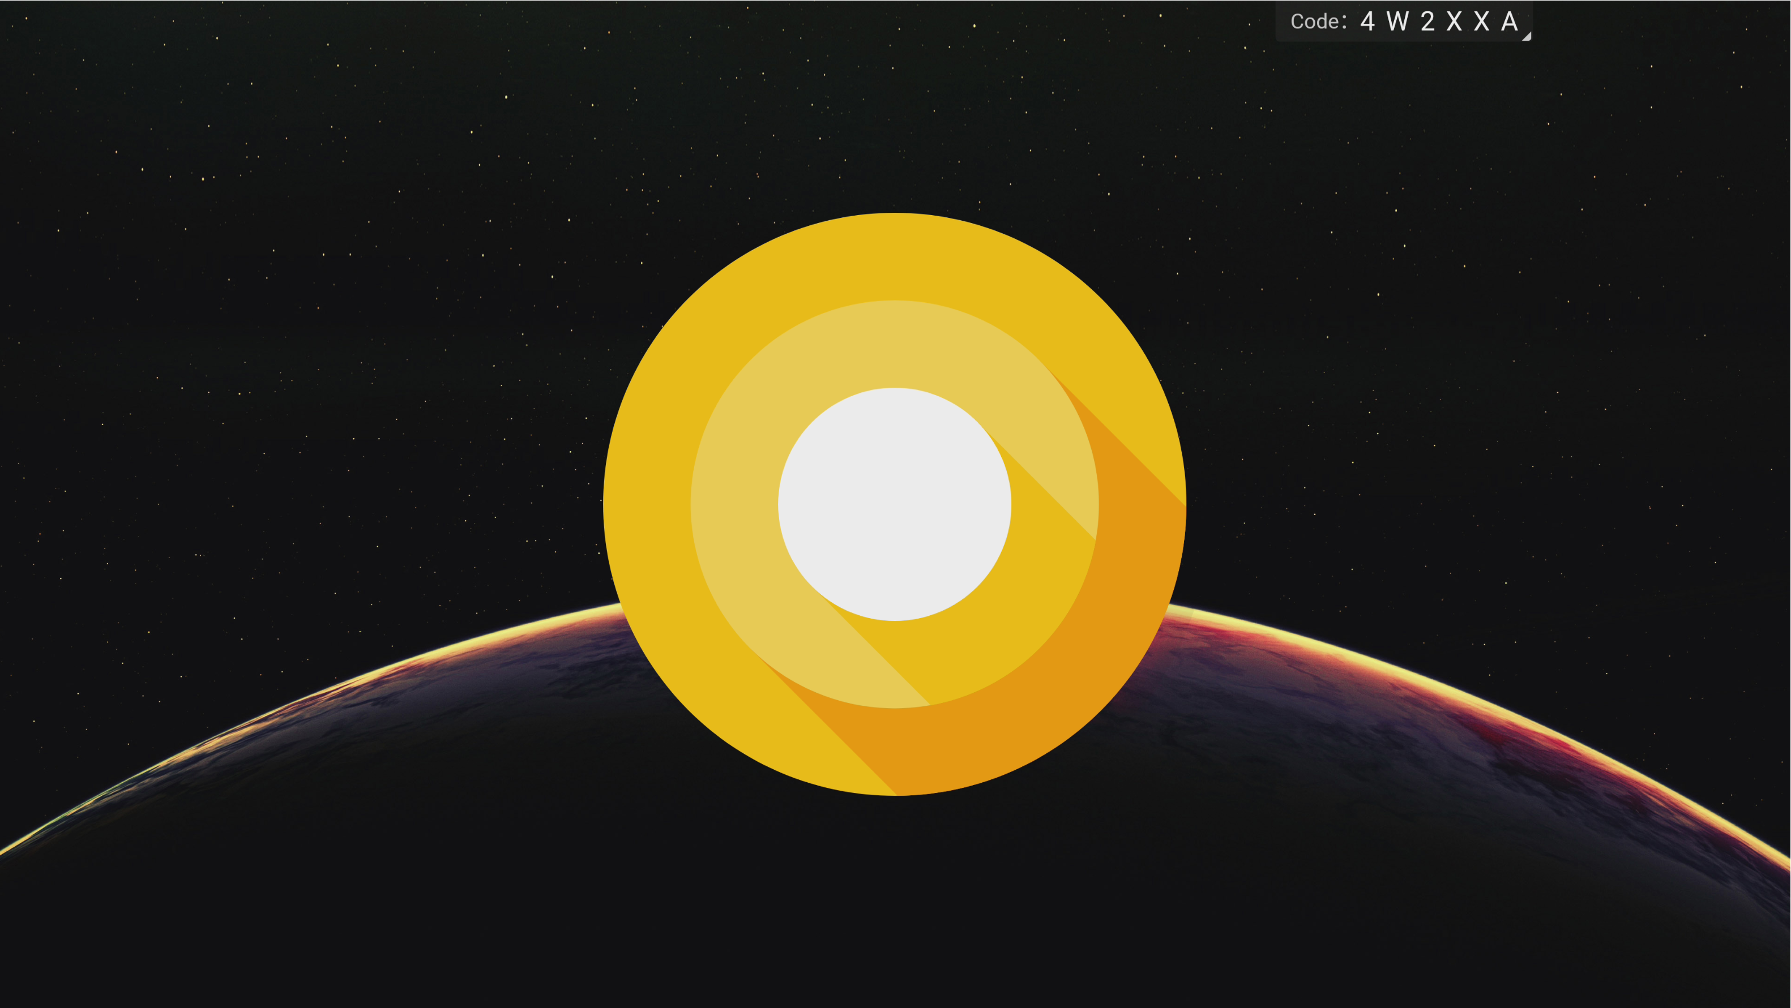

Step 3: Return and repeat Step1 and Step2.

Step 4: Quick click “Kemel version” three times.

4: “Android Setting” → “Feature Upgrade support”，and wait for automatic update.

